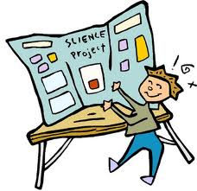
Croft Science Fair

Tuesday, March 20th 2012 @12pm-1pm

Are you in Grade 3, 4 or 5? Have you been doing Science Experiments at home or at school? Interested in showing them off?

Croft will be having a Science Fair on Tuesday, March 20th @ 12pm. Students are encouraged to participate, but it is not mandatory.

What should the project look like?

All projects must be done by students – no parents allowed The topic depends on your interests. You can do your own experiment or you can invent/modify something. It can be just about anything – nature, magnets, changes, etc.

You can use a poster board presentation that shows the scientific process (question, hypothesis, materials, procedure, data, and conclusion). Pictures, graphs and models can really help with your presentation!

How will it work?

Interested students will complete their experiment at home over the next few days/week-end. On Tuesday, March 20th, students will leave class at 11:45 am to set-up their projects in the gym. At noon students, teachers and parents may come to look at the wonderful projects.

This will be a celebration of Science!

At this time, judging will begin. Croft will choose 6 different projects to go to the District Science Fair being held at Gretna Green on Monday, March 26th from 9am-12pm.

How do I get judged?

Mainly we want the day noon hour to be fun and show off our students that love Science! To help select the 6 projects, teachers will be asking questions about your project, how you did it, what gave you the idea and what you found out. No need to be nervous – it’s all for fun!

Questions? Ask Mme Robichaud, Mme LeGresley or Mr Donovan.

