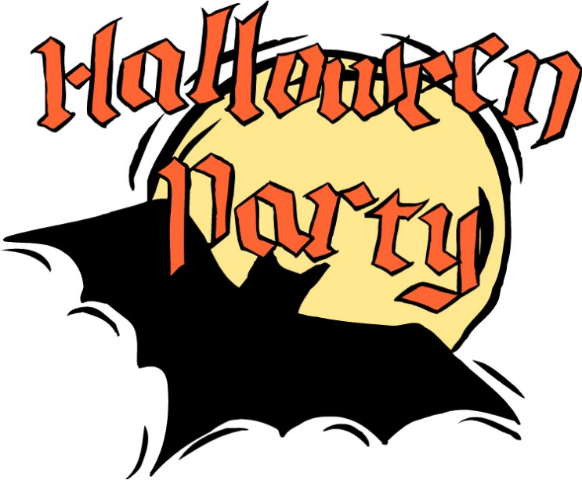
Friday October 30
Healthy Halloween at your School
Your Choice:
Sloppy Joe or Pulled Pork on a Fresh Baked Kaiser
Caesar Salad
Fresh Fruit Halloween Dessert Surprise
White Milk
$5.75
It will be a Freaky Friday with this spooky event. Please circle your child’s choice of Sloppy Joe or Puled Pork Sandwich and send the money with your child to school!

