Dear Parents: 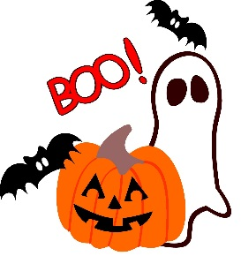

The Croft Home and School Association is currently planning the upcoming “Halloween Spooktacular” on October 28, 2016. We are looking for Donations for the event.

Our Wish List is
- Boxes of Mini Chocolate bars (nut free)
- Pop
-Juice Boxes
-Popcorn Seasoning
-Glow Sticks
-Lights for decorating
-Cash donations are also welcome

Any donation, helps to cut the cost for the Home and School Association.

Thank you,

Croft Home and School Association

